Are You In or Out, Seattle?

My internship experience with King Broadcasting’s

Digital Media department in Seattle Washington.

Prepared by

Jameson Reynolds

Faculty Advisor: Greg Gagne

Internship for Computer Information Systems

Westminster College, Salt Lake City

July, 2015

Organization

Organizational Culture

Organizational Structure

Communication

Formal Lines of Communication and Authority

Informal Lines of Communication and Authority

Problem Solving

Identification of Problems

Strategies for solving the problems

Ray Heacox is the President of Broadcasting for King Broadcasting in Seattle, Washington. He hired me over the phone in early May to serve as an intern for the Digital Media department working under its Director, Mark Briggs. The digital team had never had an intern and Ray explained as I was an atypical candidate with several years of previous work experience, I could serve two functions. The first function was as an intern to help Mark develop a new product to serve an untapped audience, and as a test case for possible future Digital Interns. I was thrilled to have found an internship that was still hiring as more than two others had not come to fruition.

On my first day I sat down with Mark and we went over the project, which had unbeknownst to me had been attempted and discussed two previous times in the previous six years. This project was Ray’s *white whale* and something he wanted to complete before he retired from broadcasting. With this new information we started walking through the steps of what had been done in the past, what worked, what didn’t, and what needed to be done from Mark’s perspective. By the end of the day I had a pretty good idea of what needed to happen next.

My job at King5 sounded simple… at first. We want to build a product so a younger generation can benefit from our content and know what’s going on in their city and be able to do fun things when they leave work. Step one would be to survey a group of people from a target audience asking them about their lifestyle through a digital form regarding their interests. The data would be collected and analyzed and we’d arrange follow up interviews to find out more about their interests based on their survey responses. Once we’d completed the interviews, we’d do an affinity mapping session based on the interview feedback. Once that was complete we’d begin developing an outline of what the product would need to offer in order to meet the needs of the target audience. We would then need to develop a prototype pitch the Prototype to the President of Broadcasting. After the pitch we would then need to determine how much content of was available to load into the product, sort and organize it and write a work flow process for the next steps…. all in 6 weeks. Did I say simple?

I started compiling a list of candidates that met the criteria for the target audience: College graduate, professional, between the ages of 20 and 35. Whether they were originally from the Seattle area mattered as did whether they were a transplant or not, we wanted a mix of both. Of the 40 emails sent out asking if the recipient would be interested in taking a 5-minute online survey and a complete a 15 minute follow call, about 80% responded yes.

I immediately started work on the [survey](https://docs.google.com/a/renovartium.com/forms/d/162LSW9uH0nTW9MsVIQhleM9ouon4acWVzsmtbDleXmk/viewform) immediately and met with Mark at the end of each day to work through the questions to ensure they were targeted enough to get the information we needed in order to ask the right question in the follow-up interview. Mark offered me feedback on how to better order the questions to make the survey flow better. Mark also appreciated the use of humor to entice the user to move to the next question. The feedback we ended up receiving on the survey when we tested it on three King employees was very positive, the humor had made it fun. The survey covered the topics of lifestyle:

* Cooking
* Outdoor Activities
* Health and Fitness
* Sustainability and Green Living
* Nightlife
* Music and Concerts
* Festivals and Local Events
* Fashion
* Shopping
* Technology
* Decorating
* DIY and Home Improvement

and asked the user rank them by their interest level. The survey also tried to attain a better sense of the users everyday life. Did they drive, what kind of mobile device do they use, how to they buy stuff, how they get around, etc.

While completing the follow up phone interviews Mark and I started looking around the various app market places to see what kind of products people already had access to. There were two that seemed to fit the bill of where we were looking to move next. The first was [*UrbanDaddy*](http://www.urbandaddy.com/mobile) available in the app store. The app offered advice on pretty much any occasion with any company. It had the curated feel of [sosh.com](http://www.sosh.com) but with an interaction that felt familiar… back to days of the first generation iPhone and the urban spoon app featured in the first commercial. The second was an app called [In or Out?](https://dribbble.com/amartlage/projects/225170-In-or-Out) but not for the same reasons as UrbanDaddy. There was a common thread found in the interviews, and it wasn’t what we were expecting: Seattleites have a fear of commitment and hate making plans. People were more likely to use the term “around” instead of “at”:

“I’ll be around Barnes and Noble down town around 7 if you want to get together for dinner”

where our transplanted were used to making plans to meet at Barnes and Noble at 7pm and then go to a specific restaurant for dinner at 730, and more than likely would have a reservation. The In or Out? app took away the option of maybe, and also forced a commitment to the decision: are you in or out? Both applications made us start thinking more about the prototype and how we wanted to move forward.

Mark suggested I create what he called a “where are we now” [doc](https://docs.google.com/document/d/1VADa_plJBVQzGlcszGo5_dzKckr5VmgzkIKUqg2Qp7I/edit?usp=sharing) to serve the purpose of catching up anyone who would come on to the project and bring them up to speed on where we are, and what we’d done so far. Drafting this document became critical as it truly helped me understand what the data meant to the process as without it no further development could take place. Up to this point in my career, I’d been brought in after this phase of work had been completed. I realized I was actually shaping a product, not just doing the grunt work. Mark referred to this as Blue Sky, ‘this is the fun part, the Blue Sky thinking, it’s before we come back down to earth.” He was right.

It was around this time two other King employees joined the project, Gary Love who was the Manager of Emerging Products for King and Dawn Boughton, Digital Producer for King’s Evening Magazine lifestyle show. Mark told the three of us that he wanted me to take a more active role in the management of this project and I would be it’s point of contact during my time at King. It was a pleasant surprise and a lot of responsibility. I then took the data we collected from the surveys and phone interviews and wrote up Lifestyle Resumes of everyone we had spoken to. The lifestyle resume served as a quick snap shot into each person’s life answering the questions about of how they fell into our target demographic, and what they said they were looking for in a lifestyle product. We got together the next day and started what Mark called affinity mapping. We took the categories previously mentioned and put them up on a whiteboard. We then went through the interview feedback of each person and wrote thoughts on post its. We then took the collection of post-its tried to group them with their corresponding ideas.

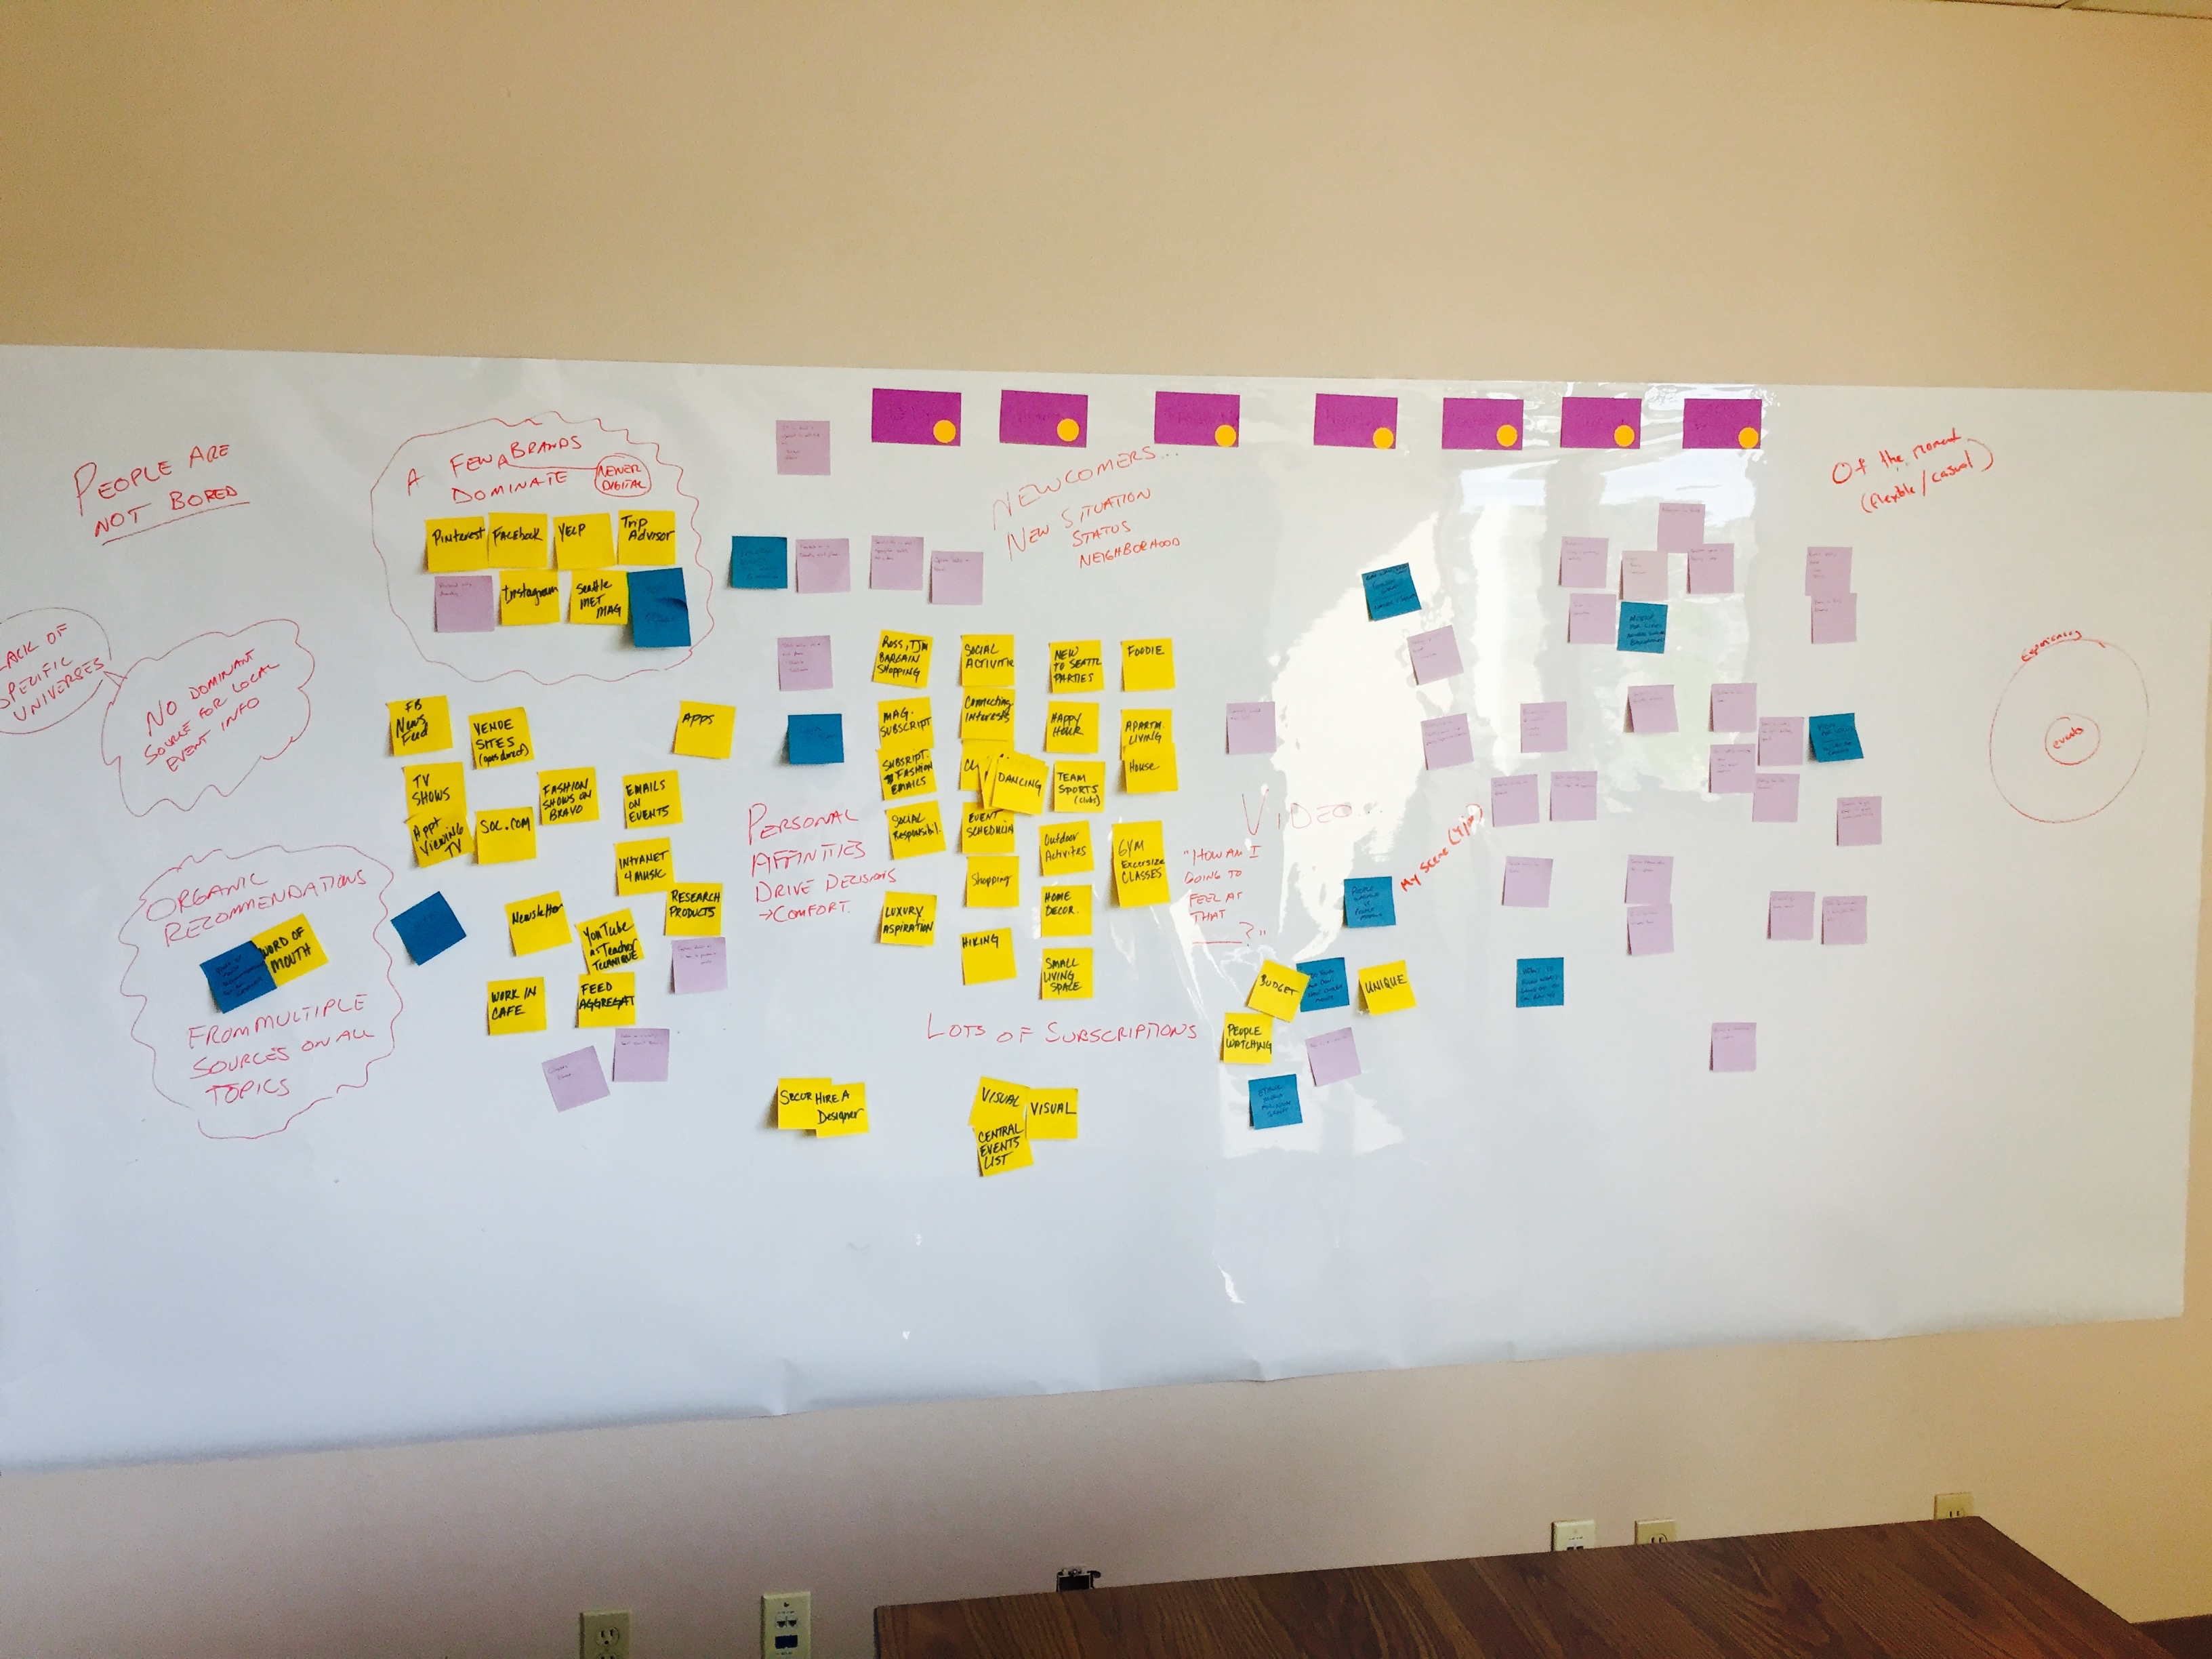

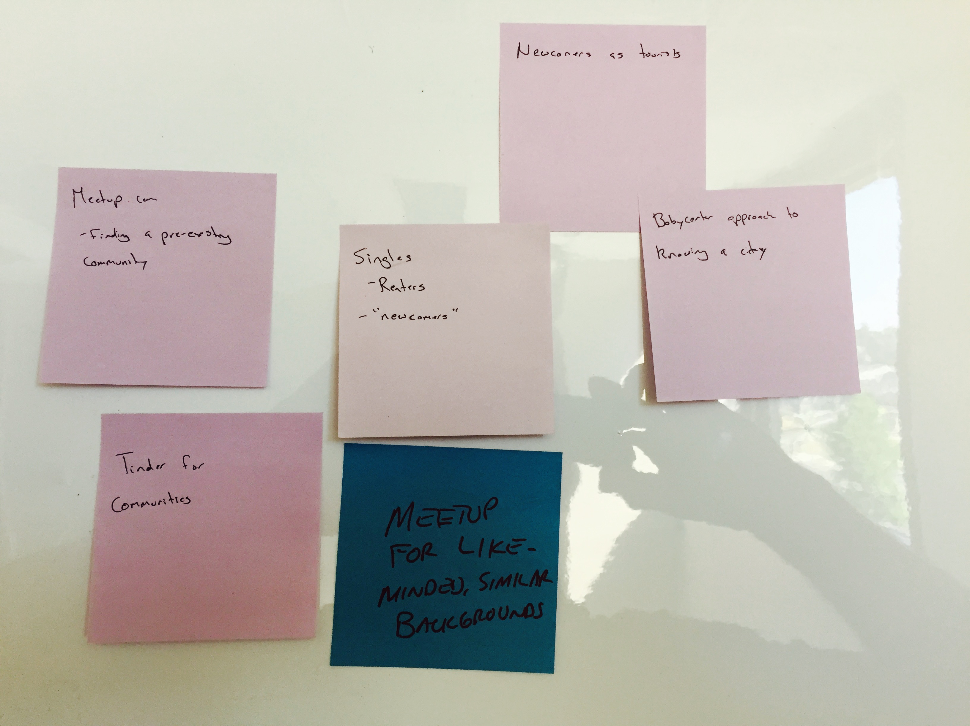

What we ultimately discovered took me by surprise. From the surveys and phone interviews we were continuously told everyone wanted a calendar, and event list, a database, something to tell them everything that was happening in order for them to pick what to do with their time. They wanted to know they weren’t going to miss out on something, option B, by picking option A. The more we listened, the more post-its we stuck to the wall, the clearer it became that everyone we had spoken to wanted a curated list of experiences they should consider… not a list of everything under the sun. They wanted to be validated on their choice when picking something to do.

I took what we found and updated the What We Know Now document and made playful [summary](https://www.evernote.com/l/AmCn-NH-QqhL26jZ_YCvYuatHod_naMjugI) for Mark, Gary, and Dawn as I could feel the amount of research beginning to wear on everyone. I prepared for our check-in with Ray and Jim Rose (Vice President of Broadcasting). The meeting went very well, our work was well received and both Ray and Jim were interested in seeing a prototype and the database of content we would be able to pull together. They also asked for revenue versus cost projections, which Mark said was his arena and he’d explain.

It was at this point Mark agreed that we needed a high level content assessment before we could move forward on any database discussions. The focus would emphasize how much we have of each asset, plus how much we can expect each year going forward. The assessment needed to manage segments, not shows, needed to fit into the categories in some way and tell us where the holes were. I began construction on what would later become known as the [Content Table](https://docs.google.com/spreadsheets/d/1W_PbG0MsHZ6JSH26lsKzrFMV9BzeEcc5P9VYI-7rk0Y/edit?usp=sharing), which started as the Assessment page.

I attempted to set up meetings with each producer of the assets we planned to leverage and found a phenomenon of my own: people had outlook but didn’t use their calendars. Their calendars were actually blank in most cases. My emails and meeting requests either went unanswered or I received a short, curt message about how they were busy and didn’t know why I wanted a meeting. This afforded me a great opportunity to start walking around the building and meeting people face to face. I started knocking on doors and introducing myself.

“Hi are you Joan? Hi Joan, I’m Jamie! I’m working for Mark Briggs to develop a product for lifestyle content and he told me you were the person to talk to about Evening Magazine. We want to get your stuff in front of more people. Do you have a minute to chat about what kind of content you’ll be producing or can I come back at a better time?”

Amazingly, to get a producer to like you and make time for you, you simply have to say, I want to put your stuff in front of a bigger audience, when can we meet? The producers will lineup to talk to you, will actually prepare you reports, and give you ideas on who else you should talk to. I made a point to send a thank you note to each of them (via email) and CC’s Mark to address two things: thanking the producer for their time, and to keep Mark in the loop of who I’d met with. So my plan worked, I went from being the annoying email to the guy bringing them a Starbucks and was going to make their life easier. I took [notes](https://www.evernote.com/l/AmB9vOvB9JFAAK8o6fXNW5pjacPDpwIx2AM) in these meetings and started formulating examples for the prototype mockups I’d be creating soon.